 | 5 | 4  AP Presentational Speaking Rubric | 3 | 2 | 1
Task completion:  Treatment of topic | Effective treatment of topic within the context of the task | Generally effective treatment of topic within the context of the task | Suitable treatment of topic within the context of the task | Unsuitable treatment of topic within the context of the task | Almost no treatment of topic within the context of the task
Task completion: Compare and Contrast | Clearly compares the student’s own community with the target culture, including supporting details and relevant examples. | Compares the student’s own community with the target culture, including some supporting details and mostly relevant examples. | Compares the student’s own community with the target culture, including a few supporting details and examples. | Presents information about the student’s own community and the target culture, but may not compare them; consists mostly of statements with no development. | Presents information only about the student’s own community or only about the target culture, and may not include examples; does not compare cultures.
Task completion: Understanding of target culture | Demonstrates understanding of the target culture, despite a few minor inaccuracies. | Demonstrates some understanding of the target culture, despite minor inaccuracies. | Demonstrates a basic understanding of the target culture, despite inaccuracies. | Demonstrates a limited understanding of the target culture, may include several inaccuracies. | Demonstrates minimal understanding of the target culture, generally inaccurate.
Task completion:  Organization & Transition words | Organized presentation; effective use of transitional elements or cohesive devices | Organized presentation; some effective use of transitional elements or cohesive devices | Some organization; limited use of transitional elements or cohesive devices | Limited organization; ineffective use of transitional elements or cohesive devices | Little or no organization; absence of transitional elements and cohesive devices
Language control:  Comprehensibility | Fully understandable, with ease and clarity of expression; occasional errors do not impede comprehensibility | Fully understandable, with some errors which do not impede comprehensibility | Generally understandable, with errors that may impede comprehensibility | Partially understandable, with errors that force interpretation and cause confusion for the listener | Barely understandable, with frequent or significant errors that impede comprehensibility
Language control:  Vocabulary | Varied and appropriate vocabulary and idiomatic language | Varied and generally appropriate vocabulary and idiomatic language | Appropriate but basic vocabulary and idiomatic language | Limited vocabulary and idiomatic language | Very few vocabulary resources
Language control:  Grammar, Syntax, Usage | Accuracy and variety in grammar, syntax, and usage, with few errors | General control of grammar, syntax, and usage | Some control of grammar, syntax, and usage | Limited control of grammar, syntax, and usage | Little or no control of grammar, syntax, and usage
Language control:  Register  (level of formality) | Mostly consistent use of register appropriate for the presentation. | Generally consistent use of register appropriate for the presentation, except for occasional shifts. | Use of register may be inappropriate for the presentation with several shifts. | Use of register is generally inappropriate for the presentation. | Minimal or no attention to register.
Language control:  Pronunciation, Intonation, Pacing | Pronunciation, intonation, and pacing make the response fully comprehensible; errors do not impede comprehensibility | Pronunciation, intonation, and pacing make the response mostly comprehensible; errors do not impede comprehensibility | Pronunciation, intonation, and pacing make the response generally comprehensible; errors occasionally impede comprehensibility | Pronunciation, intonation, and pacing make the response difficult to comprehend at times; errors impede comprehensibility | Pronunciation, intonation, and pacing make the response difficult to comprehend; errors impede comprehensibility
Language control:  Self-correction | Clarification or self-correction (if present) improves comprehensibility | Clarification or self-correction (if present) usually improves comprehensibility | Clarification or self-correction (if present) sometimes improves comprehensibility | Clarification or self-correction (if present) usually does not improve comprehensibility | Clarification or self-correction (if present) does not improve comprehensibility

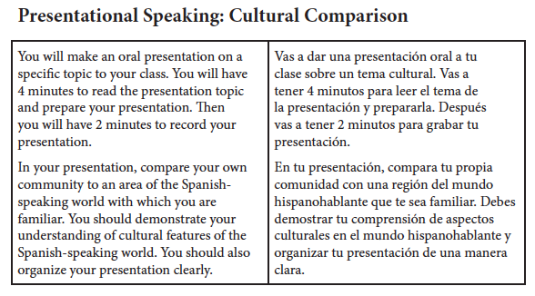
Sample question

EJEMPLO:
